** A**

**Project Report**

on

**Automatic Weed Detection using CNN**

submitted as partial fulfillment for the award of

**BACHELOR OF TECHNOLOGY**

**DEGREE**

SESSION 2023-24

in

**Computer Science and Engineering**

By

Sarthak Agarwal (2000290100136)

Shubham Kumar Gupta (2000290100152)

Yash Garg (2000290100195)

**Under the supervision of**

Dr. Dilkeshwar Pandey

**KIET Group of Institutions, Ghaziabad**

Affiliated to

**Dr. A.P.J. Abdul Kalam Technical University, Lucknow**

(Formerly UPTU)

**May, 2024**

**DECLARATION**

We hereby declare that this submission is our own work and that, to the best of our knowledge and belief, it contains no material previously published or written by another person nor material which to a substantial extent has been accepted for the award of any other degree or diploma of the university or other institute of higher learning, except where due acknowledgment has been made in the text.

Date:

Signature

Name: Sarthak Agarwal

Roll No.: 2000290100136

Signature

Name: Shubham Kumar Gupta

Roll No.: 2000290100152

Signature

Name: Yash Garg

Roll No.: 2000290100195

## CERTIFICATE

This is to certify that Project Report entitled Automatic Weed Detection which is submitted by Sarthak Agarwal, Shubham Kumar Gupta, and Yash Garg in partial fulfillment of the requirement for the award of degree B. Tech. in the Department of Computer Science & Engineering of Dr. A.P.J. Abdul Kalam Technical University, Lucknow is a record of the candidates own work carried out by them under my supervision. The matter embodied in this report is original and has not been submitted for the award of any other degree.

.

**Supervisor Name: Dr. Vineet Sharma**

**Dr. Dilkeshwar Pandey HOD (CSE)**

**(Professor)**

ACKNOWLEDGEMENT

It gives us a great sense of pleasure to present the report of the B. Tech Project undertaken during B. Tech. Final Year. We owe special debt of gratitude to Dr. Dilkeshwar Pandey, Department of Computer Science & Engineering, KIET, Ghaziabad, for his constant support and guidance throughout the course of our work. His sincerity, thoroughness and perseverance have been a constant source of inspiration for us. It is only his cognizant efforts that our endeavors have seen light of the day.

We also take the opportunity to acknowledge the contribution of Dr. Vineet Sharma, Head of the Department of Computer Science & Engineering, KIET, Ghaziabad, for his full support and assistance during the development of the project. We also do not like to miss the opportunity to acknowledge the contribution of all the faculty members of the department for their kind assistance and cooperation during the development of our project.

We also do not like to miss the opportunity to acknowledge the contribution of all faculty members, especially Ms. Shivali Tyagi, of the department for their kind assistance and cooperation during the development of our project. Last but not the least, we acknowledge our friends for their contribution in the completion of the project.

Date:

Signature:

Name: Sarthak Agarwal

Roll No.: 2000290100136

Signature:

Name: Shubham Kumar Gupta

Roll No.: 2000290100152

Signature:

Name: Yash Garg

Roll No.: 2000290100195

ABSTRACT

Weeds are becoming a serious threat to the agricultural sector, which is acknowledged as the foundation of the Indian economy but is currently experiencing production issues. Plants that grow in inappropriate places are known as weeds, and they compete with crops for vital resources like water, light, nutrients, and space. Weed detection plays a crucial role in precision agriculture, facilitating targeted herbicide application and minimizing environmental impact. In recent years, the integration of computer vision and machine learning has revolutionized weed detection, offering efficient and accurate solutions for farmers. This paper presents a comprehensive review of automatic weed detection techniques, focusing on recent advancements and emerging trends. This competition lowers crop yields and uses machinery inefficiently, which lowers agricultural productivity as a whole. Conventional weed control techniques include applying herbicide widely across the field or removing weeds by hand, which takes a lot of work. The latter approach, on the other hand, is considered ineffective since it pollutes the environment and offers little assistance in controlling weeds. There are financial and environmental issues associated with the widespread use of agricultural chemicals, such as fertilizers and herbicides. As a result, farmers are looking for alternatives more and more to reduce their reliance on chemicals in farming operations. Creative weed management strategies are becoming more and more necessary in response to these difficulties. The main goal is to distinguish between crops and weeds to provide a focused and effective weed management strategy. The agricultural industry may be able to increase productivity while lowering its impact on the environment and relying less on chemical solutions by implementing cutting-edge technologies for accurate weed identification and targeted eradication. The transition in weed control techniques towards technology-based and sustainable approaches is indicative of a wider movement in the agriculture sector to investigate environmentally friendly substitutes for a future that is more robust and fruitful.

|  |  |
| --- | --- |
| **TABLE OF CONTENTS** | **Page No.** |
| DECLARATION……………………………………………………………………. | ii |
| CERTIFICATE……………………………………………………………………… | iii |
| ACKNOWLEDGEMENTS…………………………………………………………. | iv |
| ABSTRACT………………………………………………………………………..... | v |
| LIST OF FIGURES…………………………………………………………………. | viii |
| LIST OF TABLES…………………………………………………………………… | ix |
| CHAPTER 1 INTRODUCTION……………………………………………….  1.1 Introduction……………………………………………………………………….  1.2 Need for the project……………………………………………………………….  1.3 Importance of the project …………………………………………………………  1.3.1 Efficiency………………………………………………………………………..  1.3.2 Accuracy…………………………………………………………………………  1.3.3 Sustanability……………………………………………………………………..  1.3.4 Crop Yield Optimization…………………………………………………………  1.3.5 Data Insights and Decision-Making………………………………………………  1.3.6 Cost reduction……………………………………………………………………..  1.3.7 Precision Agriculture……………………………………………………………... | 01  01  02  03  03  03  04  04  04 |
| CHAPTER 2 LITERATURE REVIEW …………………………………………… | 05 |

CHAPTER 3 PROPOSED WORK……………………………………………………. 07

3.1 Methodology/Planning of Work……………………………………………………. 07

3.1.1 Collection of Data Set…………………………………………………………… 07

3.1.2 Trends in recent years……………………………………………………………. 08 3.1.3 Deep neural networks…………………………………………………………... 09 3.1.4 Procedure……………………………………………………………………… 11

CHAPTER 4 RESULT AND DISCUSSION………………………………………… 13

4.1 Result……………………………………………………………………………… 13

4.2 Discussion………………………………………………………………………… 14

4.2.1 Precision Agriculture…………………………………………………………… 14

4.2.2 Efficiency and Speed……………………………………………………………. 14

4.2.3 Scalability and Adaptability…………………………………………………….. 14

4.2.4 Integration with Agricultural Machinery………………………………………... 15

4.2.5 Challenges and Future Directions………………………………………………. 15

CHAPTER 5 CONCLUSION AND FUTURE WORK……………………………… 16

5.1 Conclusion……………………………………………………………………….. 16

5.2 Future scope……………………………………………………………………… 17

REFERENCES……………………………………………………………………….. 18

APPENDEX1…………………………………………………………………………. 20

**LIST OF FIGURES**

|  |  |  |
| --- | --- | --- |
| **Figure No.** | **Description** | **Page No.** |
| 3.1 | Approach diagram of weed detection | 08 |

3.2 Framework to train and test deep learning models 10

3.3 CNN Model Architecture 12

**LIST OF TABLES**

|  |  |  |
| --- | --- | --- |
| **Table. No.** | **Description** | **Page No.** |
| 3.1 | Dataset Classes | 07 |

|  |
| --- |
|  |

**CHAPTER 1**

**INTRODUCTION**

* 1. **Introduction**

Accounting for almost 23% of GDP and employing 59% of the country's total workers in 2016, agriculture is a significant sector in India. India ranks as the second-largest producer of rice, wheat, sugarcane, cotton, and groundnuts. Despite having only 2.4% of the world's land and 4% of its accessible water resources, Indian agriculture manages to supply food to 17.5% of the world's population. Since the inception of the Green Revolution, the rice and wheat systems in India have played crucial roles in the global food economy. The food produced, particularly rice, not only feeds India's population of 1.25 billion but also contributes to international trade through exports.

The agriculture sector in India faces volatility due to its reliance on rainfall, especially for crops like rice, which are sown in the kharif season and require abundant water. This highlights the need for consistent efforts to enhance crop productivity and meet the growing demands of the population. To achieve this, there is a necessity to innovate and develop technologies that can effectively reduce weed growth. Weeds are adaptable plants that thrive in various conditions and compete with crops for resources, ultimately leading to yield and quality losses. Therefore, addressing weed management is crucial for sustaining agricultural productivity and meeting food demands.

The base of the Indian economy depends a lot on farming, which supports the lives of about half of the people in the country. Since farming is so important, it's really necessary to make sure farmers are using the best methods to grow crops efficiently and get good yields. One big problem for farmers is telling the difference between the plants they want to grow and the ones they don't during the cleaning process. This might seem small, but it's actually super important because it affects how many crops they get and how good they are. That's why it's crucial to find new ways to help farmers with this.

Weeds are unwanted plants that grow alongside the ones farmers want to grow. They compete with the good plants for things like nutrients, sunlight, water, and space. Weeds can steal the stuff the good plants need to grow well, which means the harvest might not be as good. So, it's really important to stop weeds from growing as much as possible. Also, weeds tend to grow faster than the crops farmers want. This is because the seeds or roots of the weeds are already in the ground, just waiting for the right conditions to start growing. So, farmers need to regularly remove weeds, which is a lot of work and takes up time.

Doing this by hand is tough and takes a long time. Figuring out which plants are which is a big part of the work. It's becoming harder because there are more and more different kinds of weeds, making it tough to tell them apart from the crops. In the past, people mainly focused on identifying the types of weeds. But now, with farming changing and more kinds of weeds popping up everywhere, it's getting harder to do this. That's why we need to come up with better and easier ways to identify weeds among crops, so farmers can manage their fields better.

* 1. **Need for the project**

Weeds can be controlled by hand removal or by introducing other chemicals called Herbicides. Automatic weed detection systems address the pressing needs of modern agriculture by offering efficiency, accuracy, and cost-effectiveness in weed management. By automating the process of identifying weeds, these systems streamline labor-intensive tasks, reduce reliance on manual labor and herbicides, and minimize crop losses due to weed infestation. Timely and accurate detection of weeds contributes to environmental sustainability by reducing chemical inputs and promoting eco-friendly farming practices. Furthermore, these systems enhance crop yields by optimizing growing conditions and minimizing competition between crops and weeds for resources. Through data-driven insights, scalability, and integration with precision agriculture technologies, automatic weed detection systems empower farmers with actionable information to make informed decisions and improve overall farm productivity.

* 1. **The importance of the project**

Automatic weed detection systems are instrumental in modern agriculture for several compelling reasons. These systems utilize advanced technologies such as machine learning, computer vision, and robotics to identify and manage weeds efficiently and accurately. Their importance stems from their ability to address critical challenges faced by farmers and contribute to sustainable agricultural practices.

**1.3.1 Efficiency:** Automatic weed detection systems streamline the process of identifying and managing weeds, saving significant time and labor. Manual weed identification is a labor-intensive task that requires substantial human effort. By automating this process, these systems reduce the need for manual labor, allowing farmers to allocate their resources more efficiently. This increased efficiency translates into higher productivity and cost savings for farmers.

**1.3.2 Accuracy:** One of the key advantages of automatic weed detection systems is their high level of accuracy. These systems are capable of distinguishing between various plant species with precision, surpassing human capabilities in weed identification. By accurately identifying weeds and differentiating them from crops, these systems minimize the risk of mismanagement and ensure effective weed control. This accuracy is crucial for maintaining crop health and maximizing yields.

**1.3.3 Sustainability:** Automatic weed detection contributes to environmental sustainability by reducing the overuse of herbicides and promoting eco-friendly farming practices. Traditional weed control methods often rely heavily on the indiscriminate use of chemical herbicides, which can have negative impacts on soil health, water quality, and biodiversity. By accurately targeting weed-infested areas, automatic weed detection systems minimize the need for herbicides, thereby reducing environmental pollution and preserving natural ecosystems.

**1.3.4 Crop Yield Optimization:** Effective weed management is essential for optimizing crop yields. Weeds compete with crops for essential resources such as sunlight, water, and nutrients, leading to reduced crop growth and lower yields. Automatic weed detection systems enable timely intervention against weed infestations, preventing yield losses and ensuring optimal growing conditions for crops. By maintaining weed-free fields, these systems contribute to maximizing crop productivity and profitability for farmers.

**1.3.5 Data Insights and Decision-Making:** Automatic weed detection systems provide farmers with valuable data insights that empower them to make informed decisions. By analyzing patterns of weed growth and distribution, these systems offer actionable information for optimizing farm management practices. Farmers can use this data to adjust their weed control strategies, allocate resources more effectively, and improve overall farm productivity and profitability.

**1.3.6 Cost Reduction:** Automated weed detection systems offer significant advantages by minimizing the expenses related to manual labor and herbicide usage. By precisely identifying and addressing weed-infested areas, these systems enable farmers to optimize resource allocation, resulting in substantial cost reductions. This targeted approach not only minimizes the need for labor-intensive manual weed removal but also reduces the reliance on chemical herbicides, thereby promoting more sustainable and cost-effective farming practices. Additionally, by efficiently managing weed control, farmers can mitigate crop losses and maximize yields, further enhancing the economic benefits of automated weed detection technologies.

**1.3.7** **Precision Agriculture:** Automatic weed detection is a key component of precision agriculture, allowing farmers to apply resources (such as water and fertilizers) precisely where needed. This targeted approach enhances resource efficiency and reduces environmental impact.

In summary, automatic weed detection systems play a crucial role in modern agriculture by increasing efficiency, accuracy, and sustainability.

**CHAPTER 2**

**LITERATURE REVIEW**

Much work has gone into categorizing weeds and crops. Crop and weed classification has always been a laborious process. The authors used a histogram based on color indices to identify three classes of weeds: apple scab, carpetweed, and crabgrass. They tested their methods using CNN, and each class had an accuracy of 93%. There are other models available as well, such as GoogLeNet. AlexNet has also undergone testing and has demonstrated high accuracy in weed detection, with a f1 score of over 95%. Furthermore, studies utilizing CNN for weed detection in unsupervised training data collection have been conducted. Research has been done on the 93% accuracy rate of CNN models in the detection of broad leaf weed in pastures. The authors present CNN models that achieve a 94% classification accuracy for 16 plant species, including weeds. Predicting the growth stage of weed species has been proposed using similar work with an accuracy of 80%. The authors looked into using CNNs to detect carpetweed and grass weeds in the soil, and they found that they could do so with more than 90% accuracy and an average accuracy of over 95% across all images. This paper compares deep learning models and conventional machine learning algorithms for seed classification. Background segmentation was used to obtain a good accuracy of 93.8%. The authors have demonstrated that CNNs are very effective at learning useful feature representations for 16 different plant species with high precision. It has been suggested that different methods and systems for classifying weeds and crops be introduced into the literature. The CNN model has been attempted to be used by the writers to solve the issue. Finding weeds Human existence has always depended on agriculture. Throughout the last century—and especially in the last fifteen years—agriculture has started to become more mechanized and digitalized. This development and automation have led to a near-complete standardization of labor flow. The information will be utilized to predict which weeds will emerge from the crop using Convolutional Neural Networks (CNNs) and a deep learning base model. This will identify any undesired weeds and provide recommendations for herbicides. For weed control, a machine vision technique might identify crops. Weeds in agricultural fields have been identified by its features, which include size, shape, spectral reflection, and texture. They have shown how to identify weed by size in this document. The automatic application of herbicides and the use of texture and size characteristics to identify crops and weeds An image processing algorithm for weed control and crop discovery has been developed. "Using computer vision to identify unwanted weeds in early-stage crops" Application of computer vision to identify unwanted weeds in a single area that affects agriculture. A Picture Processing has been developed and completed across neural networks to reach the region of interest. Several techniques, including segmentation, ANN, and picture acquisition, have been proposed. In order to achieve the same level of light intensity as before, they had to overcome a number of important challenges, one of which was obtaining the mask and identifying the regions of interest. In this case, the method was improved by applying herbicides.

**CHAPTER 3**

**PROPOSED WORK**

**3.1 Methodology/Planning of work**

**3.1.1 Collection of Data Set**

For our experimental setup, we utilized a dataset sourced from the Kaggle website, consisting of approximately 6268 plant images, all of which are in PNG format. This dataset was partitioned into a training set and a validate set, with a validate size ratio of 0.2 .

Subsequently, the training set consists of 5015 images, while the test set comprises 1253 images, totaling the initial 6268 images in the dataset. Our model was trained using the training set with 5015 images over 30 epochs, resulting in a comprehensive training process encompassing the entirety of the available image samples.

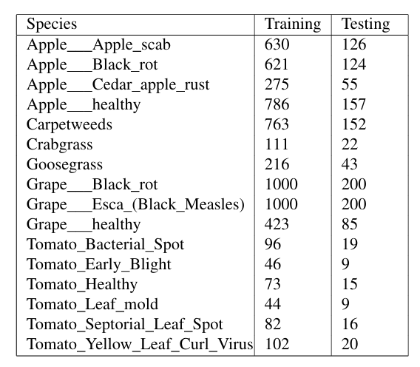

Table 3.1 Dataset Classes.

**3.1.2 Trend in recent year**

Deep learning algorithms have been helpful in recent years for effectively analyzing text, picture, and spectrum data. Artificial intelligence uses a variety of deep learning methods to make it easier to identify weeds in photos. These algorithms are effective in analyzing data and identifying distinctive characteristics. Each digital image can be recognized as a 2D array of values, where each value corresponds to a greyscale code between 0 and 255. The convolutional, pooling, and dense layers get these pixel values after which they are fed. Throughout this process, weights are adjusted in accordance with how much the output and true label differ from one another. The methodologies employed in this investigation will be covered in the parts that follow.

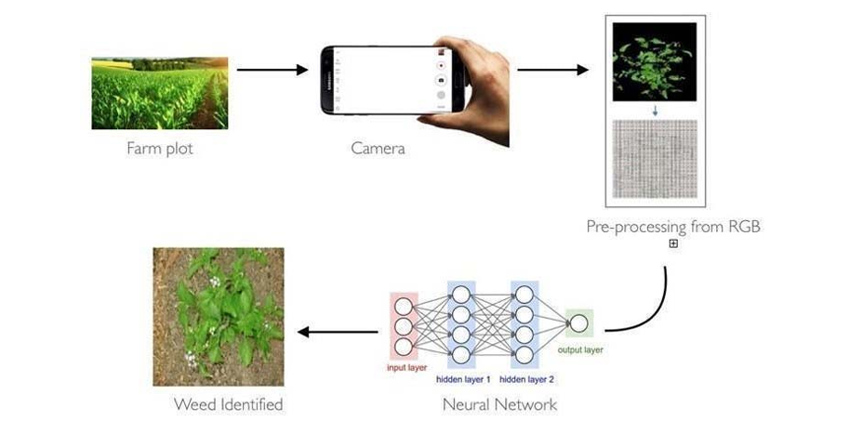

Fig. 3.1 Approach diagram of weed detection

**3.1.3** **Deep Neural Networks**

The main objective of the proposed methodology is to detect weeds. The convolutional neural network is proposed for weed detection. The architecture of the proposed methodology is shown in Figure 1. We tried to use CNN with few conv2d layers, dropout, and max pooling, and dense layers. Deep Learning (DL) is a type of machine learning algorithm characterized by sequential layers. Unlike traditional machine learning methods that necessitate manual feature extraction, DLautomatically selects features. A popular DL model known as Convolutional Neural Network (CNN) efficiently extracts features from input data, particularly in image analysis tasks. CNN’s layered architecture allows it to identify and classify elements/pixels with minimal preprocessing. Typically, a CNN model consists of four main layers: convolutional, activation function, pooling, and fully connected layers (FCN) for clas sification purposes.

The convolutional layer extracts features from the image using mathematical filters; the features can be edges, corners, or alignment patterns, which give the output a feature map that serves as input to the next layer. The application of CNNs involves a series of steps: first, data preparation (image ac quisition and labeling); second, CNN selection and configuration (hyperparameter tun ing); third, CNN training (through GPU processing Graphics Units); fourth, evaluation of CNN performance (usual metrics: average precision (mAP), recall, F1-score, and Confu sion Matrix, among others); and fifth, model deployment (real-world applications).

The pooling layer reduces the resolution by reducing the dimension of the feature map in order to minimize the computational cost.

The connection layer sends the feature maps obtained from the previous layer to the fully connected neural network layer, which contains the activation function used to recognize the final image.

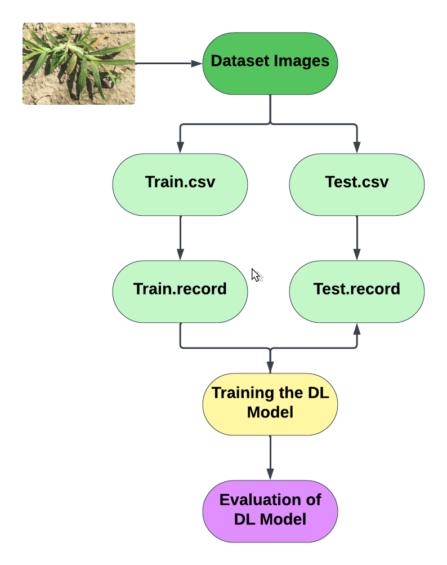

Fig 3.2 Generalized framework to train and test deep learning models.

**3.1.2.1 Input Layer:** This layer normalizes the input pixel values to the range [0, 1]. It ensures consistency in input data, which is essential for effective training.

**3.1.2.2 Convolutional Layers(Conv2D):** The model starts with a convolutional layer that applies 16 filters to the input im ages. Each filter performs a convolution operation, extracting features from the input image patches using a kernel size of (3, 3). ReLU activation function is applied to introduce non-linearity.- MaxPooling2D: Following each convolutional layer, a max-pooling layer reduces the spatial dimensions of the feature maps by taking the maximum value within a specified window (2x2 in this case). This helps in reducing computational complexity and extracting dominant features.

**3.1.2.3 Flattening Layer:** Flatten: After multiple convolu tional and pooling layers, the Flatten layer converts the multi dimensional feature maps into a one-dimensional array. This step is necessary to connect the convolutional layers with the densely connected layers.

**3.1.2.4 Densely Connected Layers:** Dense: The flattened output is passed through a fully connected layer with 128 neurons. Each neuron is connected to every neuron in the previous layer. ReLU activation is used here to introduce non linearity.- Dense (Output Layer): Finally, another dense layer with 16 neurons is added, which serves as the output layer for classification. The number of neurons in this layer corresponds to the number of classes (assuming a multi-class classification problem). The output layer typically uses a softmax activation function to compute the probabilities of each class.

**3.1.4 Procedure**

In this part we will understand the characterisation process for weeds into all the classes which we considered, we performed image processing on the dataset; images in the dataset are in RGB color code and have various dimensions (width and heights). AlexNet and GoogleNet models use three input channels corresponding to red, green and blue color codes, input dimensions for GoogleNet is (224 x 224) and AlexNet is (227 x 227). We performed image processing in two steps. In the first step, all images are resized to conform to the input layer dimensions of AlexNet and GooleNet and in second step original image is duplicated three times for input channels (Red, Green and Blue). We have used transfer learning model to extract important information from the dataset images by indentifying key details.

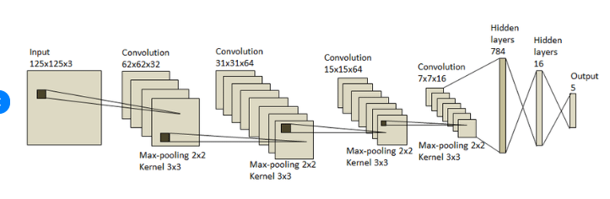

Fig 3.3 CNN Model Architecture

Our models involves numerous convolutional neural networks (CNNs) stacked over each other. We have used two pre-trained model AlexNet and GoogleNet, we have replaced bottom layers of the model by three fully connected layers which helps in uniting data extracted by previous layers. Used a softmax layer to convert a vector of kreal values into probability distribution with k- potential outcomes and we used softmax layer to normalize the output .

**CHAPTER 4**

**RESULT AND DISCUSSION**

**4.1 Result**

The outcomes of automatic weed detection are multifaceted and have profound implications for modern agriculture. Firstly, these systems drastically enhance operational efficiency by reducing the laborious and time-consuming task of manual weed monitoring and control. By swiftly identifying weeds with precision, farmers can allocate resources more effectively, optimizing both time and costs associated with weed management practices.

The research paper concludes with a thorough investigation of machine learning based automatic weed detection, emphasizing the effectiveness of various models on a particular dataset. Initial test accuracy of only 84% was obtained using an AlexNet CNN model and 90% was obtained using GoogleNet,which produced less than-ideal results. There was no overfitting or underfitting observed in our model . The obtained results demonstrate that the model can accurately and confidently identify weeds in crops.

Moreover, there is a significant effect on crop yields. Automatic weed identification systems promote healthy crop growth by reducing weed competition for vital resources like water, nutrients, and sunlight, which ultimately maximizes yields. Effective weed control and higher crop yield are directly correlated, which improves farm profitability and increases the capacity to produce food—two factors that are especially important for feeding a growing world population.Furthermore, the environmental benefits of automatic weed detection cannot be overstated. By facilitating targeted herbicide application, these systems minimize the indiscriminate use of chemicals, thereby reducing environmental contamination and mitigating adverse effects on soil health and biodiversity. The ability to precisely apply herbicides only where necessary minimizes runoff and ensures that beneficial organisms remain unharmed, fostering ecological balance within agricultural ecosystems.

**4.2 Discussion**

Automated weed detection is a critical component in modern agricultural practices aimed at improving efficiency, reducing chemical usage, and maximizing crop yield. The results and subsequent discussion of automatic weed detection systems encompass various aspects, including accuracy, efficiency, scalability, and practicality.

**4.2.1 Accuracy of Detection:**

High accuracy is paramount for any automatic weed detection system to be effective. This accuracy is typically measured by metrics such as precision, recall, and F1-score.

Studies have shown promising results with deep learning techniques, especially convolutional neural networks (CNNs), achieving high levels of accuracy in distinguishing between crops and weeds.

However, challenges still exist, particularly in diverse and cluttered agricultural environments where weeds may closely resemble crops or exhibit significant variability in appearance.

**4.2.2 Efficiency and Speed:**

Alongside accuracy, the efficiency and speed of weed detection systems are crucial for real-world applications.

Rapid processing of large-scale agricultural landscapes is essential to enable timely intervention and management strategies.

Advances in hardware acceleration, such as the use of graphics processing units (GPUs) and specialized ASICs (Application-Specific Integrated Circuits), have significantly improved the speed of detection algorithms.

**4.2.3 Scalability and Adaptability:**

Scalability refers to the ability of the detection system to perform consistently across various crop types, environmental conditions, and geographical regions.

While many automatic weed detection systems demonstrate promising results in controlled environments, their performance in real-world scenarios with diverse vegetation, lighting conditions, and soil types remains an ongoing area of research.

The adaptability of detection algorithms to different agricultural practices, such as conventional tillage versus no-till farming, also influences their practical utility.

**4.2.4 Integration with Agricultural Machinery:**

Seamless integration of weed detection systems with agricultural machinery, such as tractors or drones, is critical for practical implementation.

Real-time feedback and decision-making capabilities can optimize the application of herbicides or enable targeted mechanical weed control methods, thereby minimizing environmental impact and reducing operational costs.

**4.2.5 Challenges and Future Directions:**

Despite significant progress, several challenges persist in the field of automatic weed detection.

Robustness to environmental variability, data annotation requirements for training deep learning models, and the need for annotated datasets spanning diverse geographic regions and crop types are among the primary challenges.

Future research directions include the development of multi-sensor fusion techniques, incorporation of advanced machine learning algorithms for semi-supervised or unsupervised learning, and the exploration of explainable AI methods to enhance transparency and trust in decision-making processes.

In conclusion, automatic weed detection holds immense potential for revolutionizing modern agriculture by enabling targeted and sustainable weed management practices. Continued research efforts aimed at improving the accuracy, efficiency, scalability, and practicality of detection systems are essential for realizing this potential and addressing the challenges associated with weed control in agricultural landscapes.

**CHAPTER 5**

**CONCLUSION AND FUTURE WORK**

**5.1 Conclusion**

Weed detection using convolutional neural networks is a promising technique that facilitates agricultural operations automation. This study illustrated CNN models’ applicability in the field of weed detection. Two machine learning models (Alexnet, GoogLeNet) have been used in this work to identify weeds that are present in the f ield. Real-time crop and weed detection based on the CNN models’ decisions is one area of possible future investigation. Our model’s accuracy in the experiment was 93.2%.

We concluded that our suggested approach might more accurately and swiftly predict weeds than the manual method. This demonstrates the great potential of deep learning in the agricultural sector. You will be able to identify weeds much more quickly by employing this strategy. Future research in the deep learning sector of agriculture may benefit from this approach. We have created a user-friendly web interface, especially for farmers as part of our creative project. Farmers are empowered by this interface, which makes it easy for them to choose photos from a gallery and upload them to the platform.

After the photos are uploaded, the interface’s built-in algorithms examine them and, as tonishingly, identify any weeds. Farmers greatly benefit from this feature, which makes it possible for them to quickly locate and eradicate weed infestations in their f ields. To further promote agricultural efficiency, we’ve included a helpful resource: a link to comprehensive guidelines on practical weed-removal techniques. This re source gives farmers the skills and information they need to successfully manage weed growth, maximizing crop yield and guaranteeing the success of their farming endeavors.

Although the system produces good outcomes, there is still much room for improvement. It is possible to create a more reliable algorithm for plant identification that can identify more species of leaves regardless of their color or form. The design can be further improved to meet farmers’ needs and offer the most possible coverage of the area.

**5.2 FUTURE SCOPE**

Convolutional Neural Networks (CNN) models, such as AlexNet and GoogLeNet, provide great promise for automatic weed detection in a variety of agricultural and environmental management applications. Precision Agriculture: Using CNN models to identify weeds can improve methods of precision agriculture. Farmers can administer targeted herbicide treatments, limiting chemical usage and environmental impact while maximizing crop pro duction, by properly recognizing and localizing weeds within crops. Crop management: By differentiating between unde sirable weeds and crops, weed detection CNN models can help monitor the health of crops. By using this data, crop management practices can be optimized by timely interven tions like selective harvesting and irrigation modifications. Environmental Conservation: By reducing the environmental impact of pesticide use, accurate weed detection using CNN models promotes sustainable agriculture methods. These sys tems support soil health, biodiversity, and overall ecosystem resilience by lowering chemical inputs. Research and Devel opment: Ongoing studies in plant biology, weed ecology, and agronomy are aided by the constant improvements made to CNN models for weed identification. These technologies aid in the advancement of scientific knowledge and the creation of creative weed management techniques by offering com prehensive insights into the distribution patterns and species composition of weeds. Programs for Crop Breeding: Weed Identification CNN models can discover characteristics linked to weed compet itiveness, which can help crop breeding efforts. With the use of this information, breeders can create crop types that are more effective in suppressing weeds, which will increase agricultural productivity and increase the crops’ resistance to weed pressure. Keep an eye on Invasive Species: In addition to agricultural environments, invasive plant species identification and monitoring in natural habitats can be facilitated by CNN models for weed detection. Invasive species conservation ef forts are aided by early discovery and management, which also lessens the negative ecological and financial effects of inva sive plant infestations. Integrated Pest Management: Complete integrated pest management techniques are made possible by combining CNN-based weed detection with other pest monitoring technologies. Farmers can optimize crop protection operations by implementing comprehensive and targeted pest management strategies by merging data on pest insects and illnesses with information on weed infestations.

**REFERENCES**

[1] Johnson, Rincy, Thomas Mohan, and Sara Paul. ”Weed detection and removal based on image processing.” International Journal of Recent Technology and Engineering (IJRTE) 8, no. 6 (2020): 347-352

. [2] Hema, M. S., V. Abhilash, V. Tharun, and D. Madukar Reddy. ”Weed Detection Using Convolutional Neural Network.”

[3] Aravind, R., M. Daman, and B. S. Kariyappa. ”Design and development of automatic weed detection and smart herbicide sprayer robot.” In 2015 IEEE Recent Advances in Intelligent Computational Systems (RAICS), pp. 257-261. IEEE, 2015

[4] Tiwari, Om, Vidit Goyal, Pramod Kumar, and Sonakshi Vij. ”An experimental setup for utilizing the convolutional neural network in automated weed detection.” In 2019 4th international conference on Internet of Things: Smart innovation and usages (IoT-SIU), pp. 1-6. IEEE, 2019.

[5] Zahoor, Saniya, and Shabir A. Sofi. ”Weed Identification in Crop Field Using CNN.”

[6] Umamaheswari, S., R. Arjun, and D. Meganathan. ”Weed detection in farm crops using parallel image processing.” In 2018 Conference on Information and Communication Technology (CICT), pp. 1-4. IEEE, 2018.

[7] Aparna,Shreya Karan,Madhumati JB,NS Shravani,Radhika Patil. “CNN based weed detection in farming - A smart approach.” [8] Haq, Mohd Anul. ”CNN based automated weed detection system using UAV imagery.” Computer Systems S

[8] Haq, Mohd Anul. ”CNN based automated weed detection system using UAV imagery.” Computer Systems Science & Engineering 42, no. 2 (2022).

[9] Subeesh, A., S. Bhole, Kamaljeet Singh, Narendra Singh Chandel, Yogesh Anand Rajwade, K. V. R. Rao, S. P. Kumar, and Dinesh Jat. ”Deep convolutional neural network models for weed detection in polyhouse grown bell peppers.” Artificial Intelligence in Agriculture 6 (2022): 47-54.

[10] Sethia, Gaurav, Harish Kumar S. Guragol, Swati Sandhya, J. Shruthi, and N. Rashmi. ”Automated computer vision based weed removal bot.” In 2020 IEEE International Conference on Electronics, Computing and Communication Technologies (CONECCT), pp. 1-6. IEEE, 2020.

[11] Paidi Sravanthi,Dr. Kunjam Nageswara Rao,Dr. G. Sita Ratnam,P. Mohan Rao. ” Weed Detection using CNN and YOLO frame work.” Journal of Engineering Sciences.

[12] P.Kavitha Reddy, R.Anirudh Reddy, Mail Abhishek Reddy, Katkam Sai Teja, K. Rohith, and K. Rahul . ”Detection of Weeds by Using Machine Learning.”

**APPENDEX1**







